**TEAM COMPETITION PROBLEM**

The Borobudur Temple, built in the 9th century, is the biggest stony Buddhist temple in the world. It is considered as one of the wonders of the ancient world. It has nine stacked platforms. The first six platforms have square form and beautifully decorated with numerous reliefs. The upper three platforms are circle, exhibiting 72 small bell-shape stupas, surrounding one large central stupa (main stupa). The altitude of the ground close to the entrance is 265 m above mean sea level. Note that the height of the temple is 35 m (referred to the top of the main stupa with respect to the ground).

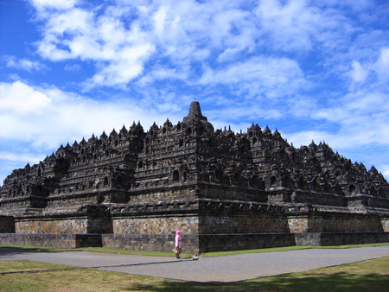

main stupa

We believe that the constructors of this temple knew astronomy quite well. In search of the possible existence of the astronomical alignment between Borobudur and some celestial bodies, we will make some measurements. Observers are distributed surrounding the temple, mainly in eastern and western sides. The coordinates of each position are given in the table below.

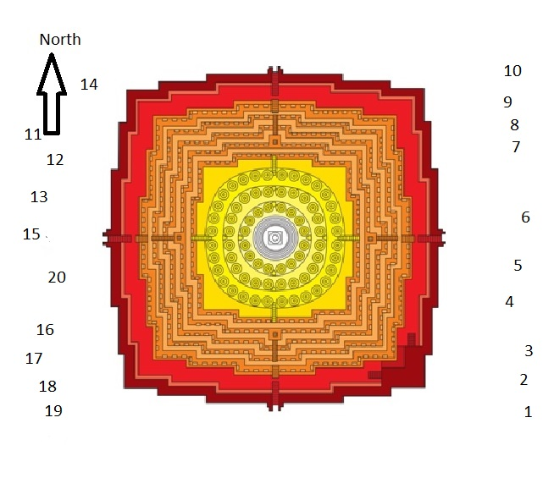

Table 1: Coordinates of observer’s positions

|  |  |  |  |
| --- | --- | --- | --- |
| **Position** | **longitude** | **latitude** | **Altitude (m)** |
| 1 | 110° 12´ 16.52″ | -7° 36´ 30.10″ | 264 |
| 2 | 110° 12´ 16.69″ | -7° 36´ 29.80″ | 264 |
| 3 | 110° 12´ 16.82″ | -7° 36´ 29.62″ | 264 |
| 4 | 110° 12´ 16.65″ | -7° 36´ 28.85″ | 265 |
| 5 | 110° 12´ 16.54″ | -7° 36´ 28.26″ | 264 |

From your position, if you observe the sky in the direction to the peak of the main stupa, determine:

1. What constellation aligned with the main stupa at the time of the observation (18:00)?
2. What celestial objects do you find around this direction?

You are provided with:

* Star chart
* Magnetic compass
* Protractor, string, and a weight

Describe your answer thoroughly.